3.9.1 Search Activity – Merial or Merial Limited
In Espacenet, find how many patent documents are in the name Merial Limited. You should avoid retrieving those documents originating from France where the assignee name is simply Merial.

Go to the USPTO granted (issued) patents database find how many patents have been granted for the applicant “Merial Limited”. Further, try out the assignee search for “Merial Limited”. Why do you think there is a difference?

After navigating to http://patft.uspto.gov/netahtml/PTO/search-bool.html or
http://patft.uspto.gov/netahtml/PTO/search-adv.htm
(the issued patents advanced search page) you will see there is a table defining field codes.

AANM is the field code for Applicant, applicant is an entity who applied for the patent in first go itself.

Answer to Search Activity
Searching for Merial gives about 3,500 hits. Searching for ‘Merial Limited’ gives less than half that number.

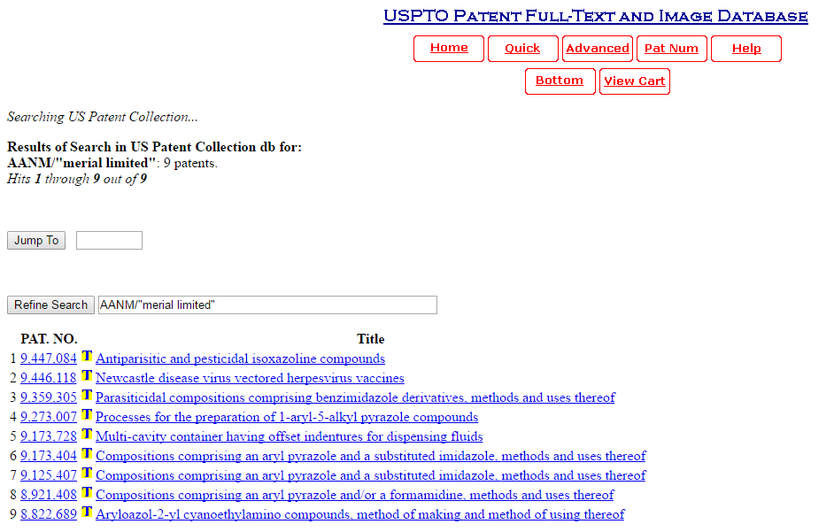

AN is the field code representing the Assignee. An Assignee is the entity who owns the granted patent. There may be more than one Assignee. A search string AN/"merial limited" will find the patents where at least one of the Assignees is “Merial Limited” but not those originating from France where the assignee name is simply “Merial”.

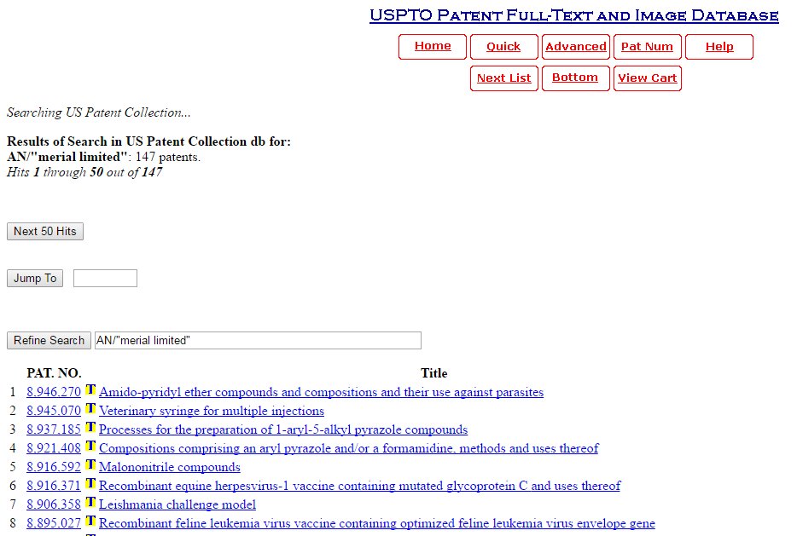

Read more about the difference between applicant and assignee.

